3/25/2022

Chirag Gaur

Deloitte

KT Session

on

**PingFederate**

**Table of Contents**

|  |  |  |
| --- | --- | --- |
| **S. No** | **Topic** | **Page No.** |
| 1. | IdP Initiated SSO   1. Define user credentials using PCV 2. Create an IdP Adapter 3. Create a SP Connection 4. Browser SSO Configuration 5. Configure Protocol Settings in SSP Connection 6. Configure Certificate in SP Connection 7. Access IdP initiated URL | 2-20  2-5  5-8  8-11  11-14  15-16  17-18  19-20 |
| 2. | PingFederate Installation Guide   1. Setting Up Virtual Machine 2. Downloading JAVA 3. Downloading License Files 4. PingFederate Installation | 21-26  21  21  22  23-26 |
| 3. | Troubleshooting Issues | 27 |

**IdP Initiated SSO**

1. **Define user credentials using PCV**

**Overview:** Password Credential Validators (PCV) allows to create user credentials manually (username and password) in ping federate. This feature provides centralized credential validation for various PingFederate components.

1. Open the terminal inside the bin folder and type the command **sudo ./run.sh** to run the PingFederate
2. 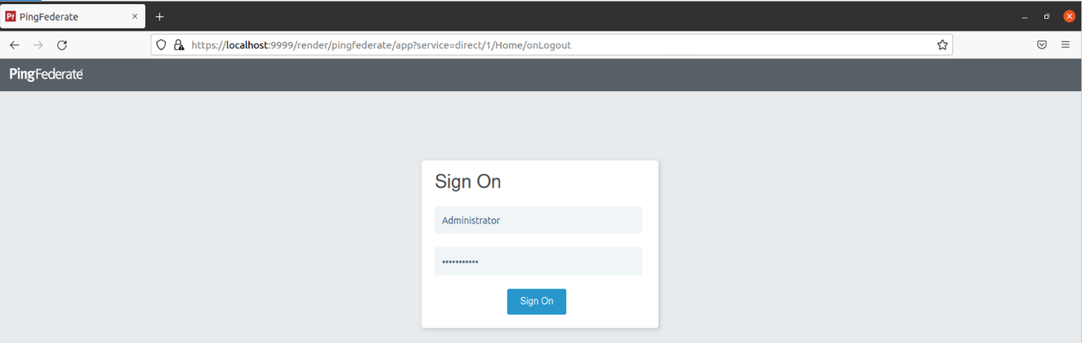 Open <https://localhost:9999/> to access the PingFederate console application. Enter the Username and Password set during installation.
3. 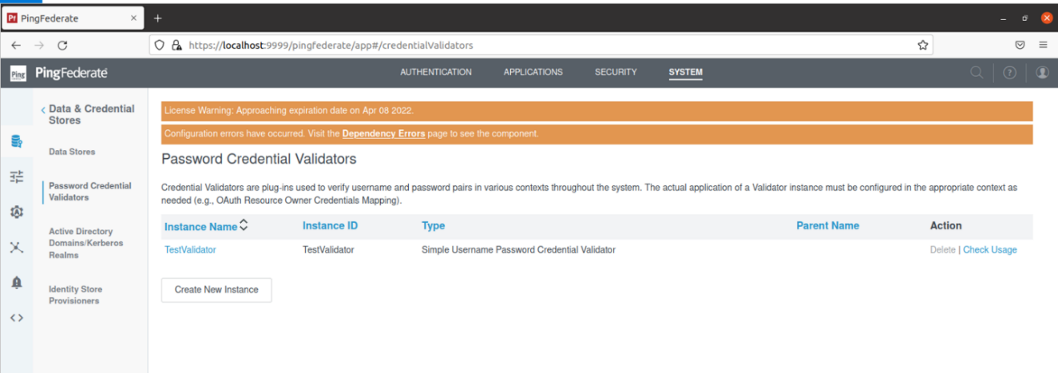Navigate to **System**  **Password Credentials Validators** and select **Create New Instance**
4. Configure the following options under the **Type** tab and Select **Next.**

* Instance name: **TestValidator**
* Instance ID: **TestValidator**
* Type: Select **Simple Username Password Credential Validator**
* Parent Instance: Select **None**

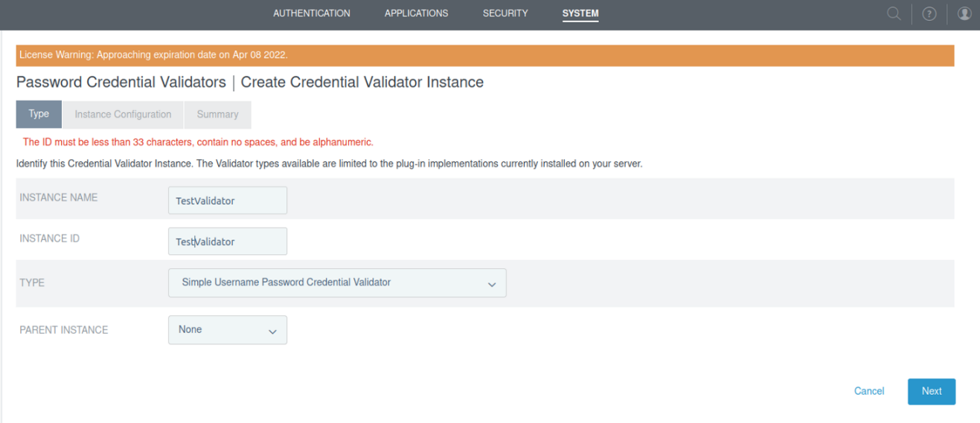

1. Select **Add a new row to ‘Users’** under the **Instance Configuration** Tab**.**

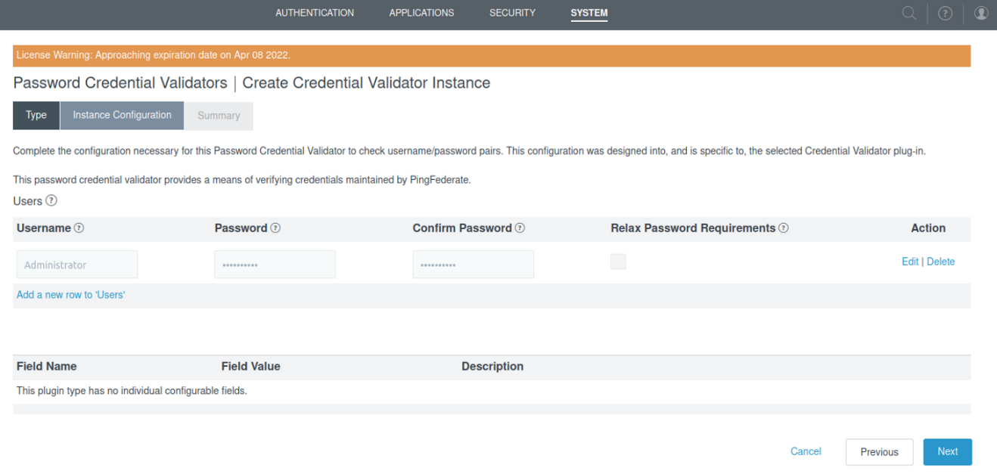

1. Configure the below options then Select **Next**.

**Note**: The username and password can be set according to user’s choice. Below configuration is just a demo.

1. Username: **Chirag**
2. Password: **12345678**
3. Confirm Password: **12345678**
4. Relax Password Requirements: **Checked**
5. 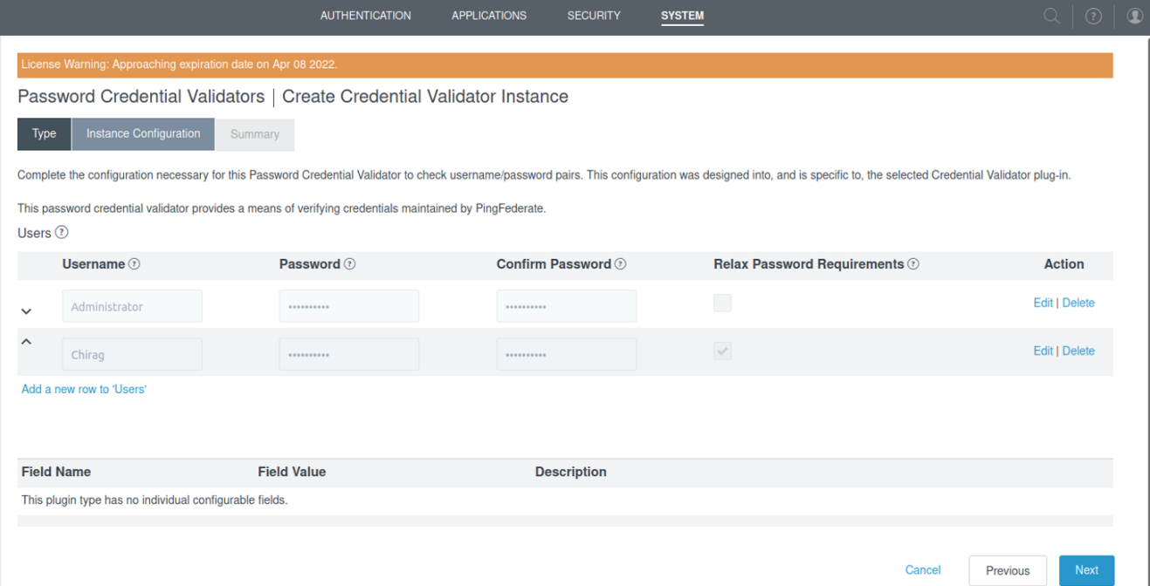Select **Update**
6. View the summary under the **Summary** Tab and Select **Save**.

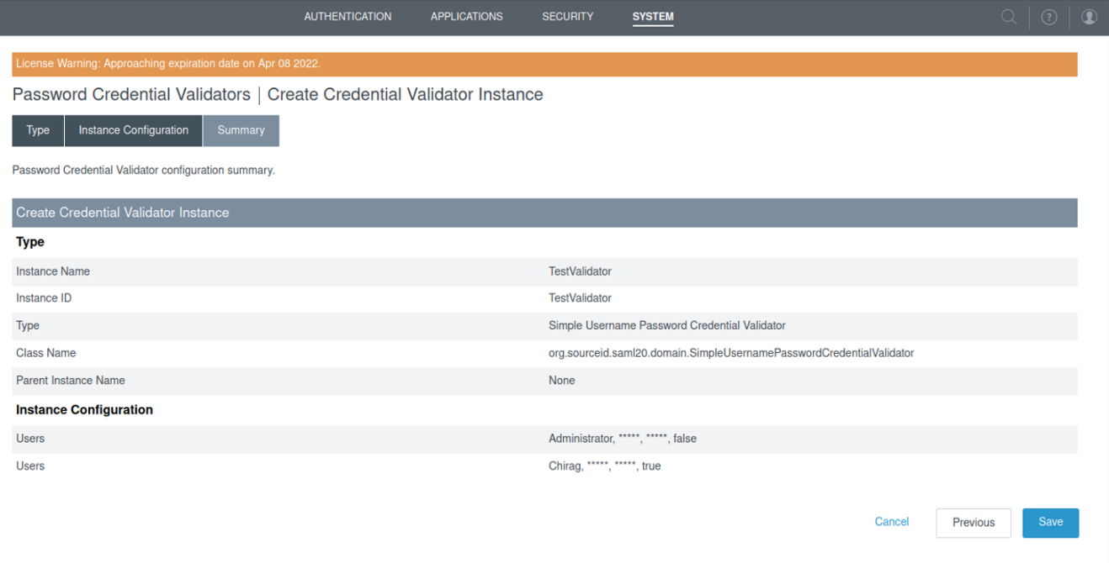

1. At this point we have created the identity of a user using PCV. Navigate to **System Password Credentials Validators** to view the Instance **TestValidator.**

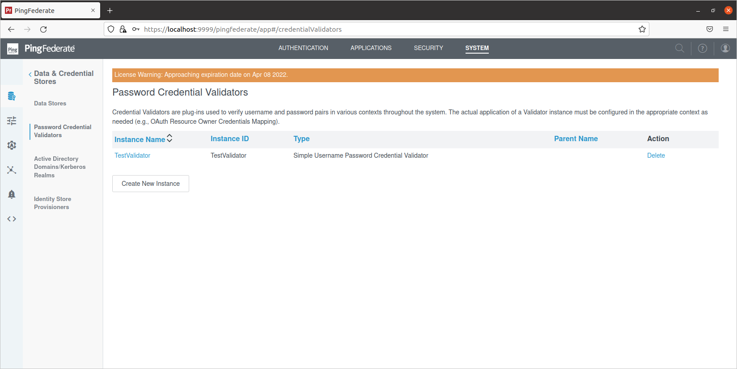

1. **Create an IdP Adaptor for Identity Provider**

**Overview:** An IdP adapter is used to provide session information and user identification to PingFederate. We must configure at least one instance of an IdP adapter in order to set up connections to SP partners. It will act on top of PCV, will fetch the information and pass it to SP

1. Navigate to **Authentication IdP Adapters** and select **Create New Instance**

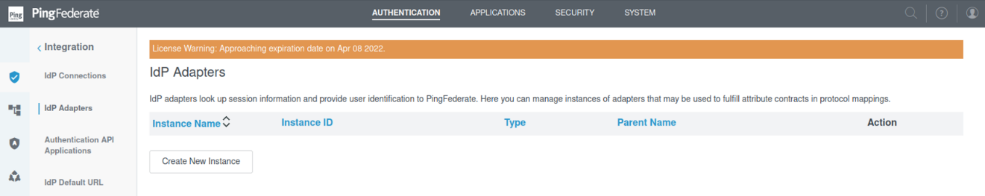

1. Configure the following options under the **Type** tab of **IdP Adapters** and Select **Next.**

* Instance name: **TestAdaptor**
* Instance ID: **TestAdaptor**
* Type: Select **HTML Form IdP Adapter**
* 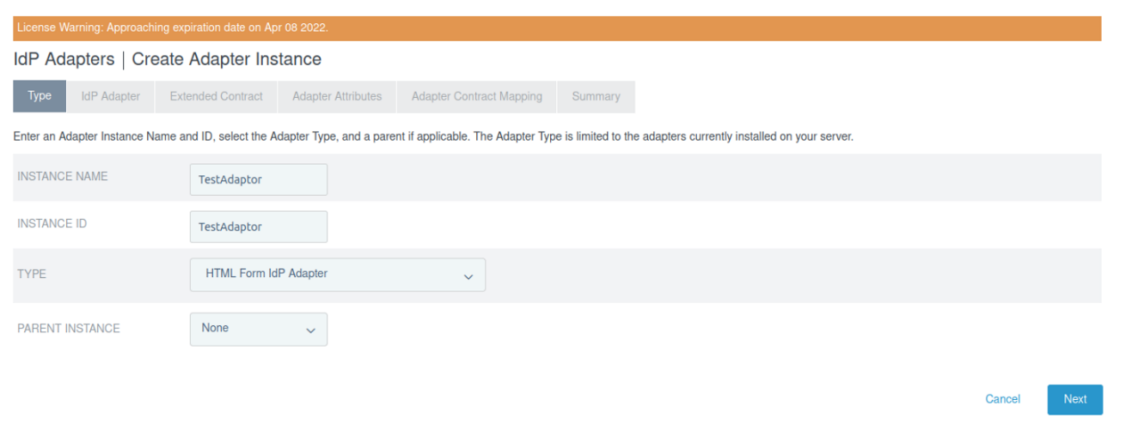Parent Instance: Select **None**

1. Scroll down to bottom of **IdP Adapter** tab and Select **Next**

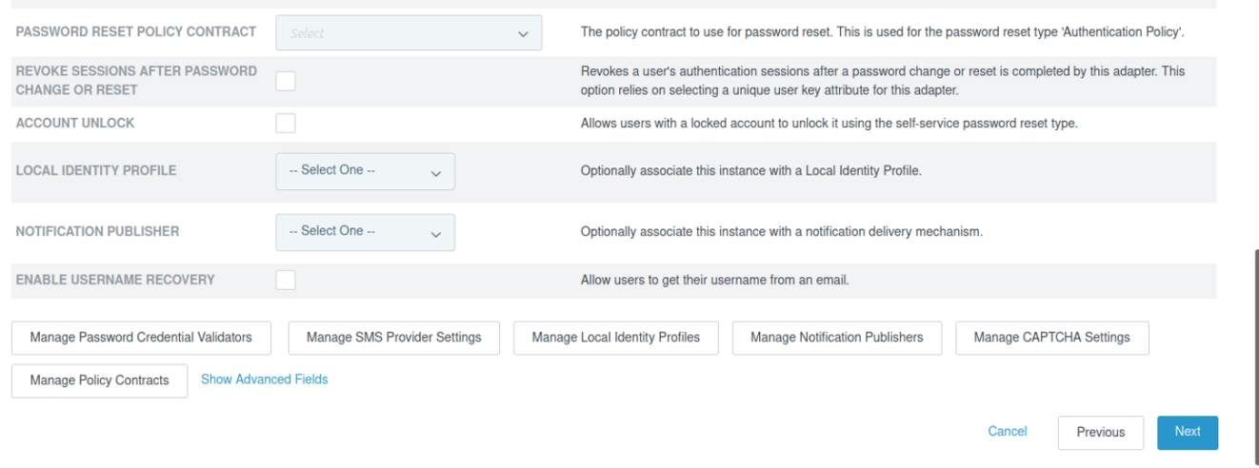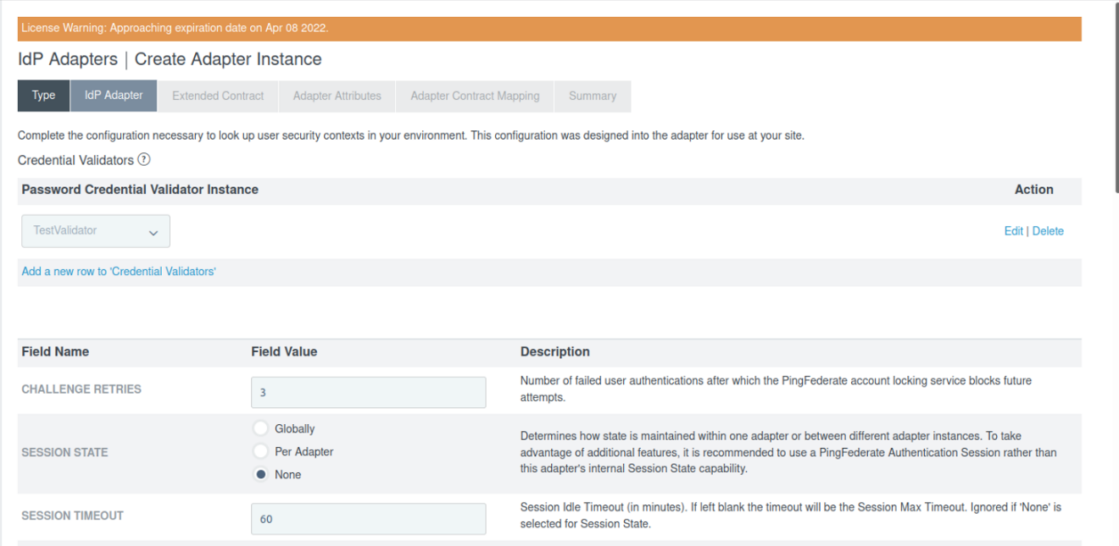

1. 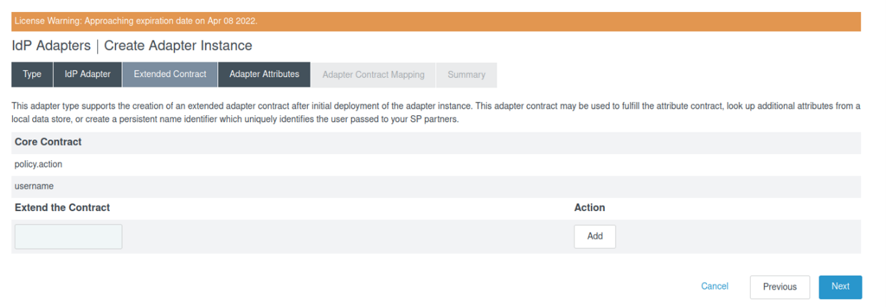Select **Next** under the **Extended Contract** tab
2. Check the **Pseudonym** box for **username** Attribute and select **Next**

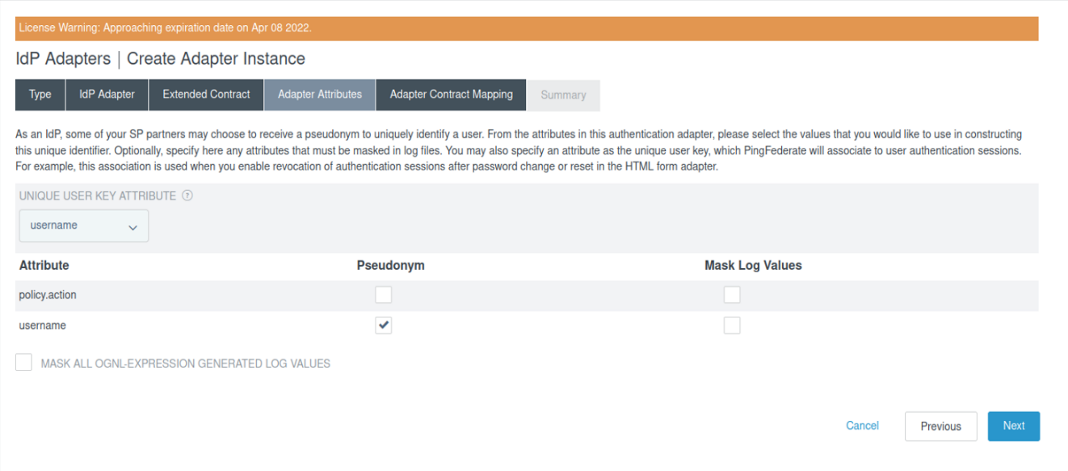

1. Select **Next** under the **Adapter Contract Mapping** tab

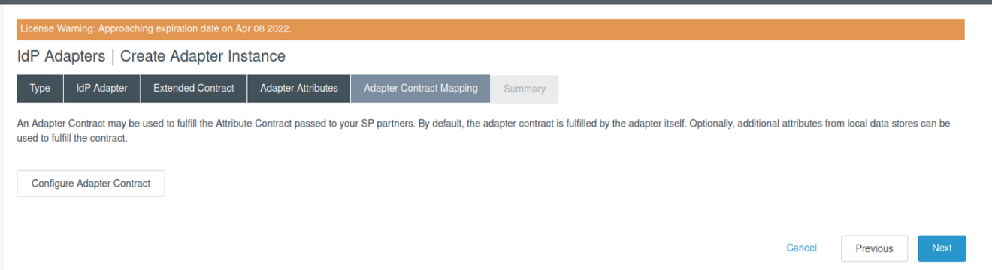

1. View the summary under the **Summary** Tab and scroll down to Select **Save**.

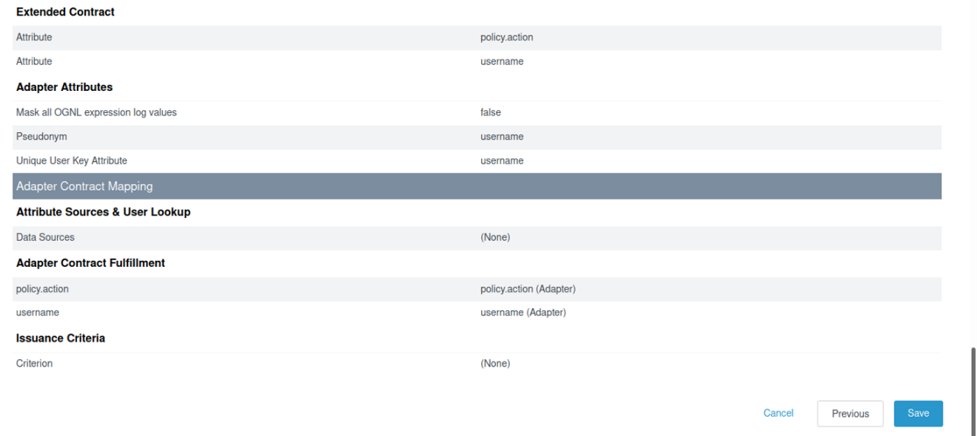

1. 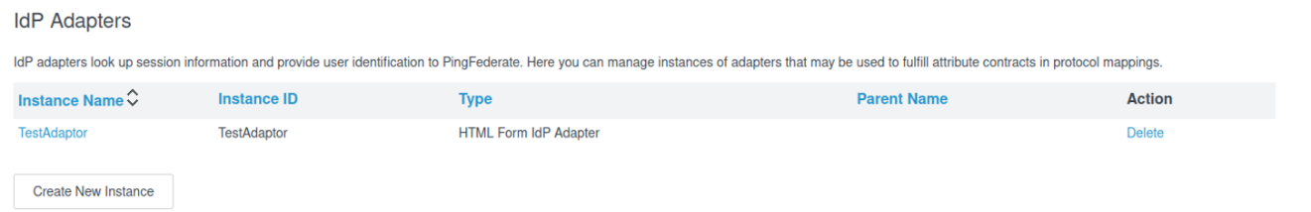At this point we have created an IdP adapter with Instance Name **TestAdaptor.**
2. **Create a SP connection**

**Overview:** SP connection is used to specify which application needs to be configured with IdP. In our case, IAM showcase file has been used to act as Service Provider and perform IdP initiated flow. We will download the metadata file from IAM showcase website and will use that metadata file later to establish a SP connection.

1. Go to the URL <https://sptest.iamshowcase.com/instructions#start> and select **DOWNLOAD METADATA** option. Save this file. This metadata file is downloaded in XML format.

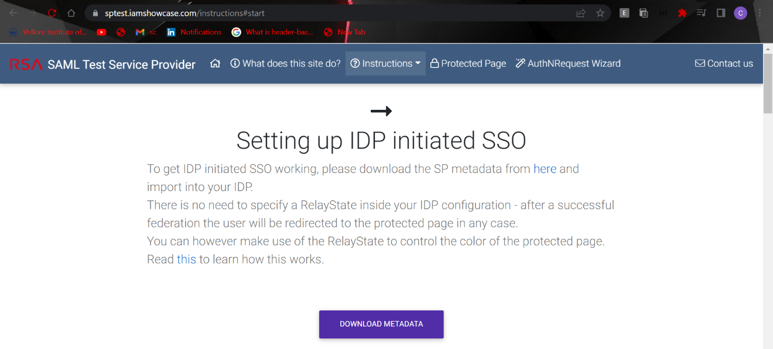

1. After downloading the file, open it and verify that the Metadata file should look like as one shown below.

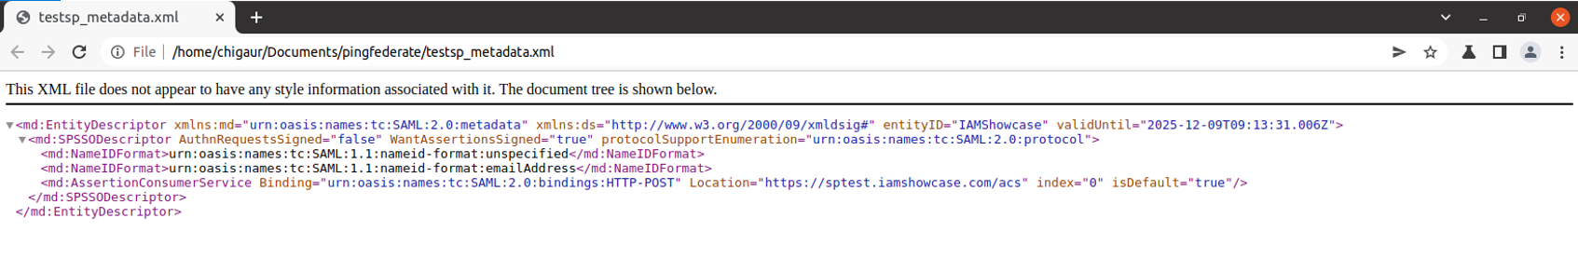

1. Navigate to **Applications SP Connections** and Select **Create Connection**

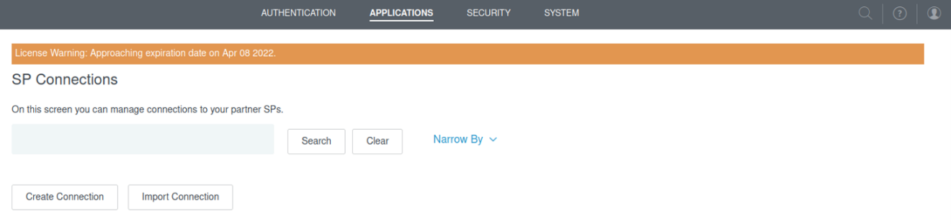

1. Under the **Connection Template** Tab, Select the option **DO NOT USE A TEMPLATE FOR THIS CONNECTION** and then Select **Next.**

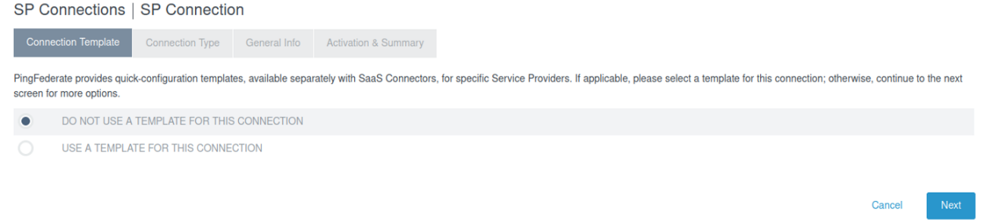

1. Configure the following options under the **Connection Type** Tab and Select **Next.**
2. BROWSER SSO PROFILES: **Checked**
3. PROTOCOL: Select **SAML 2.0**

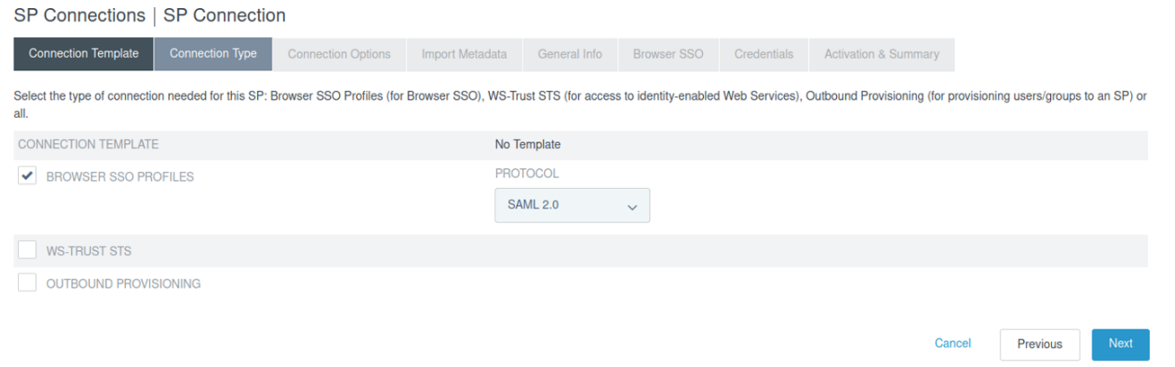

1. Select **BROWSER SSO** option under the **Connections Options** tab and then Select **Next**

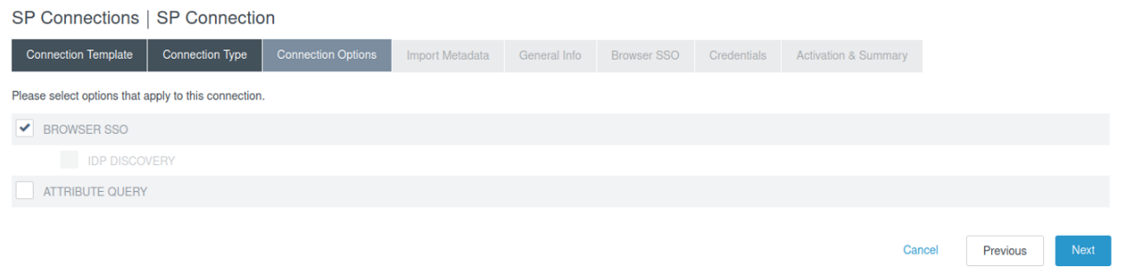

1. Under the **Import Metadata** Tab, Select **Choose File** option. Upload the metadata file that was downloaded earlier and Select **Next**.

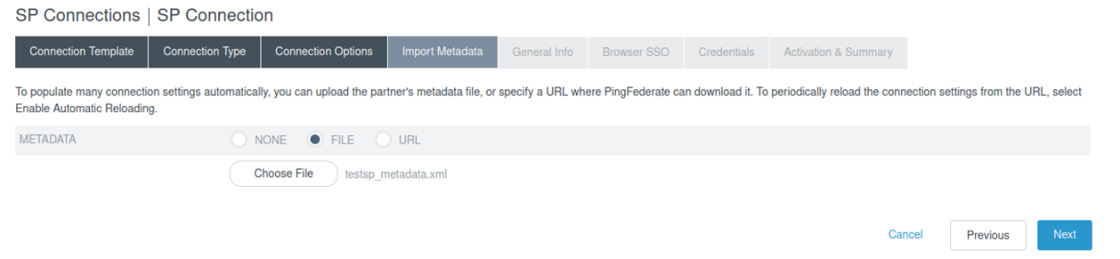

1. Select **Next** under the **Metadata Summary** Tab.

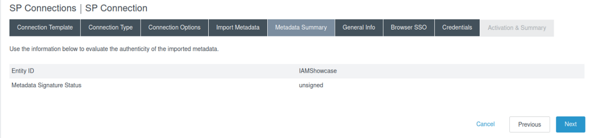

1. Scroll down to bottom of **General Info** tab and Select **Next.**
2. **Browser SSO Configuration**
3. Select **Configure Browser SSO** under the **Browser SSO** tab.

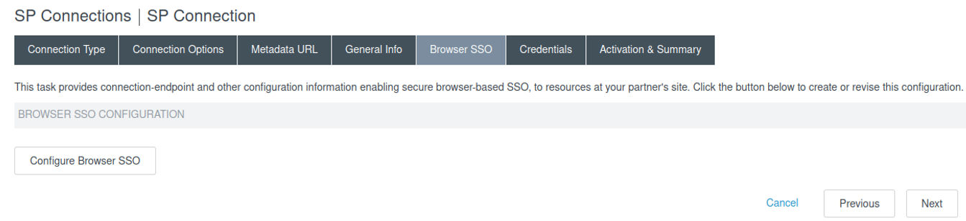

1. Check the following boxes under **Single Sign-On (SSO) Profiles** and Select **Next.**
2. IDP-INitiated sso: **Checked**
3. SP-INITIATED SSO: **Checked**

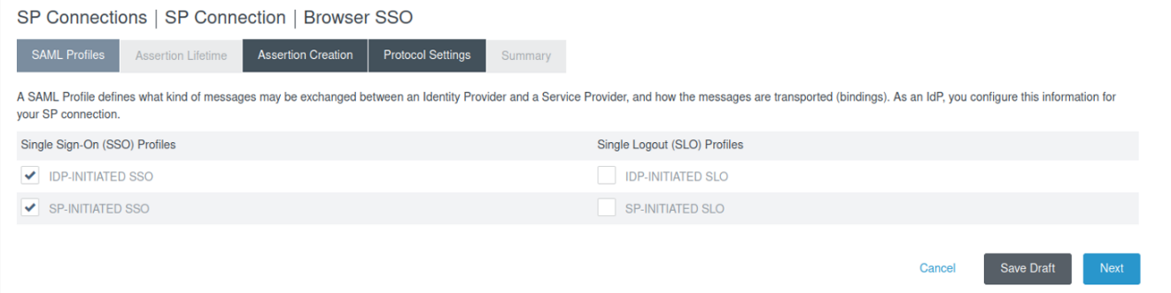

1. Select **Next** under the **Assertion Lifetime** tab

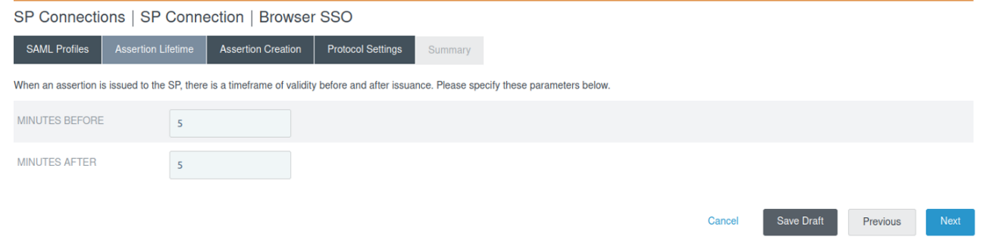

1. Select **Configure** **Assertion Criteria** under the **Assertion Criteria** tab

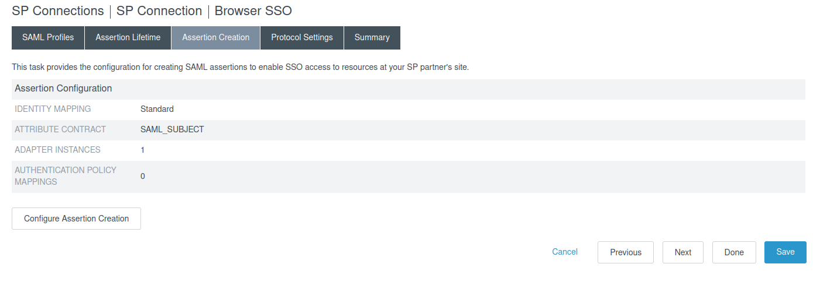

1. Select **STANDARD** option under **Identity Mapping** tab and Select **Next**

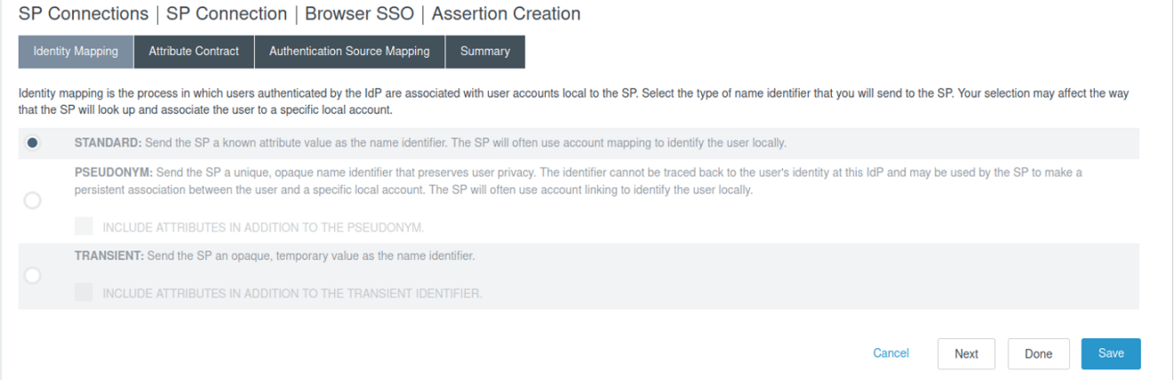

1. Choose the options in **Subject Name Format** and **Attribute Name Format** as shown in the below image. Select **Next.**

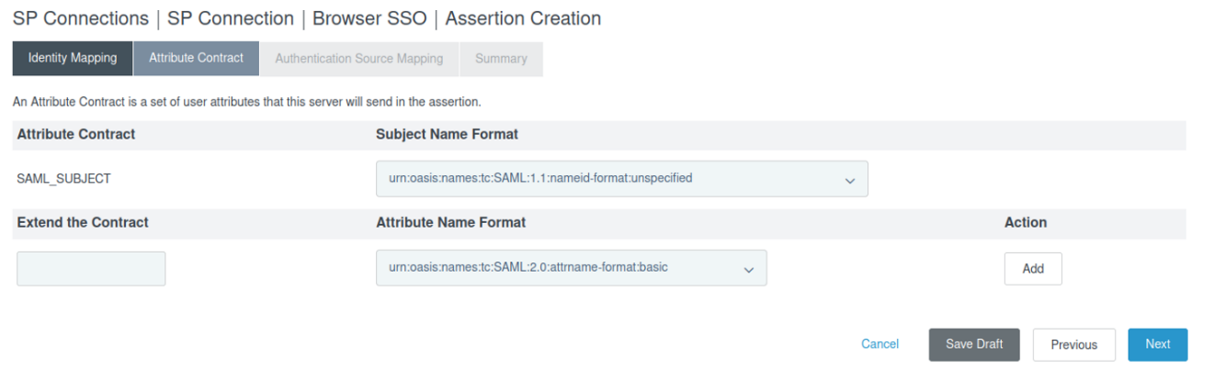

1. Navigate to **Authenticate Source Mapping** and select **Map New Adapter Instance.**
2. Choose theAdapter Instance as **TestAdaptor** and select **Next.**

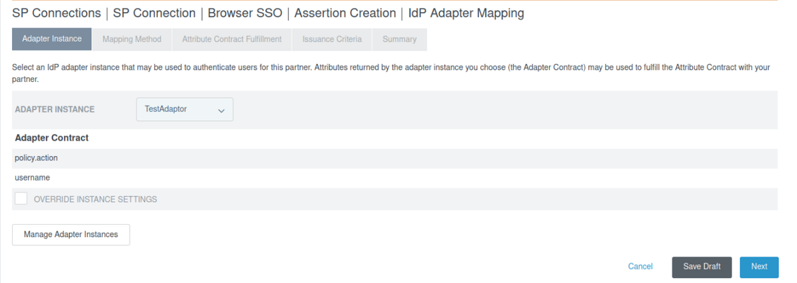

1. Select **Next** under the **Mapping Method** tab.

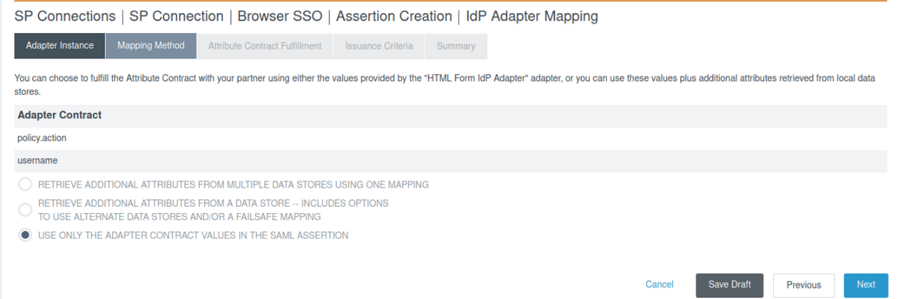

1. Configure the following options under the **Attribute Contract Fulfillment** tab.
   1. Source: **Adapter**
   2. Value: **username**
   3. 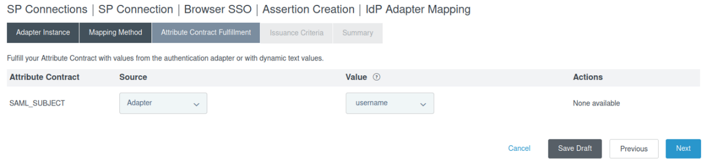Select **Next**
2. Select **Next** under the **Issuance Criteria** tab.
3. Select **Done** under the **Summary** tab

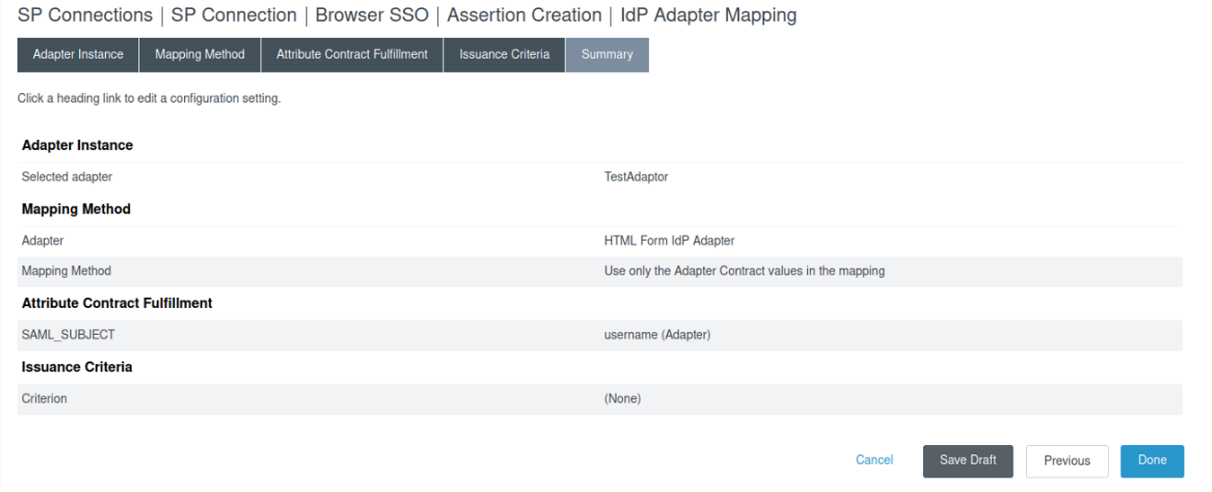

1. 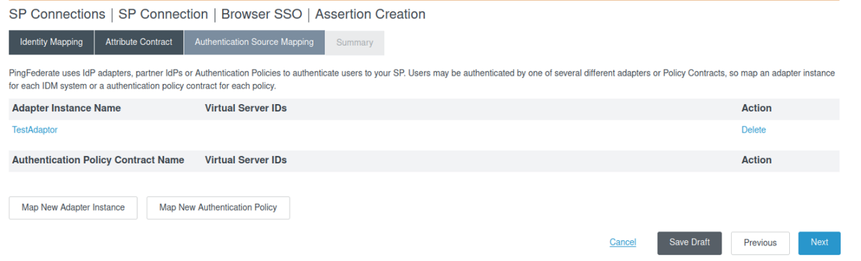At this point we have added the **TestAdaptor** in SP connection
2. Scroll down to view the Summary and select **Next**
3. **Configure Protocol Settings inside SP Connection**
4. 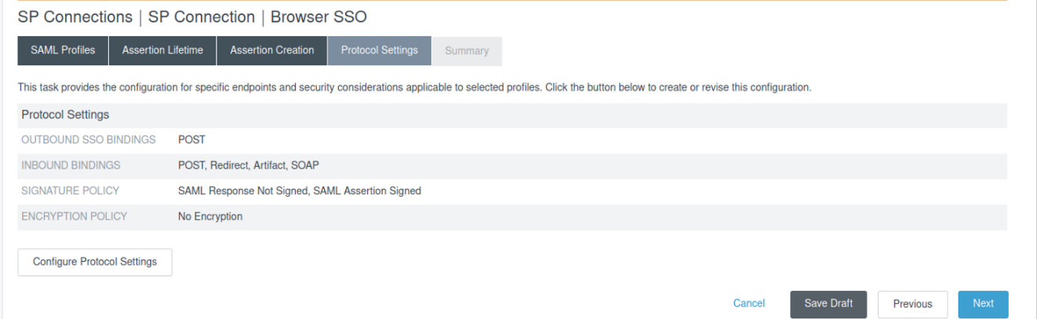 Navigate to **SP Connections Browser SSO Protocol Settings.** Select **Configure Protocol Settings**
5. Select **Next** under **Assertion Consumer Service URL** tab

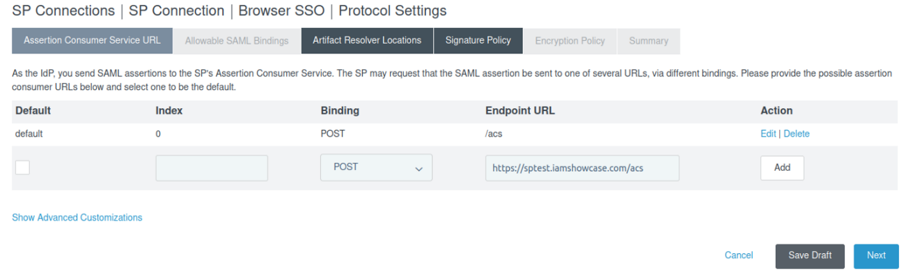Note: No need of giving the endpoint URL and binding method. The URL will automatically be fetched from metadata file which was uploaded earlier.

1. Check the options shown in the image below and select **Next**

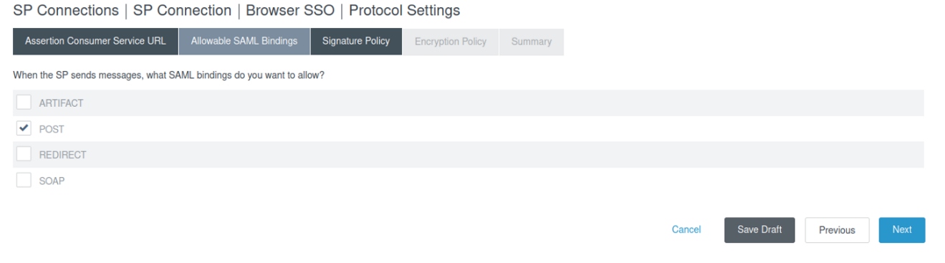

1. 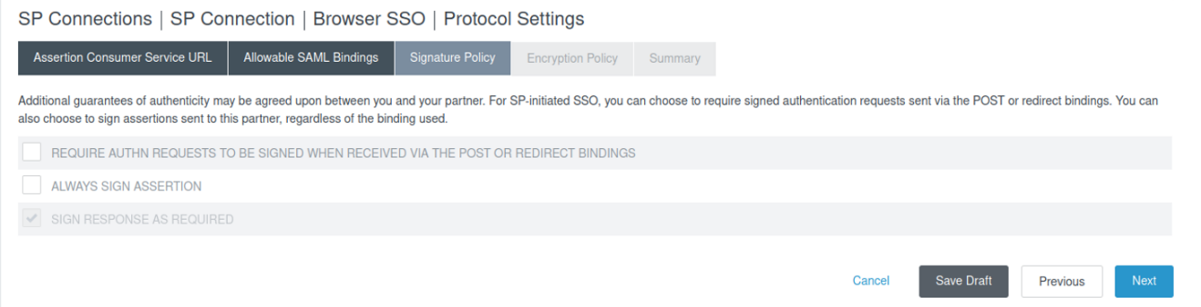Under the **Signature Policy** tab, check the option **sign response as required**. Then select **Next**
2. 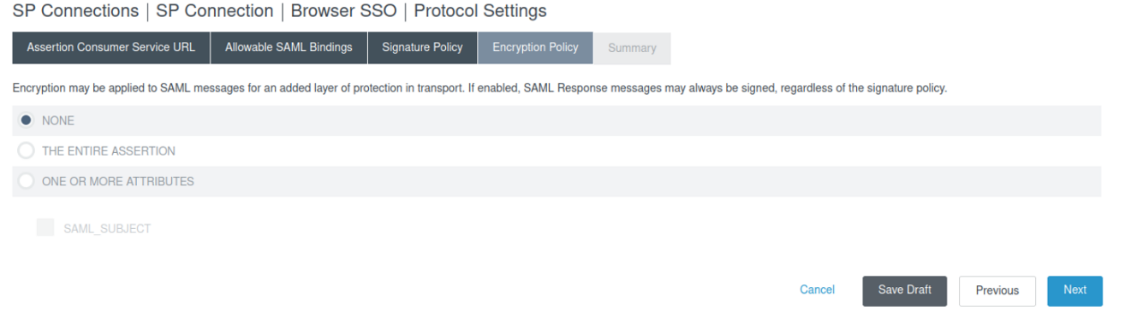Mark option **NONE** under the **Encryption Policy** Tab and Select **Next**
3. Scroll down to view the summary and select **Done.**

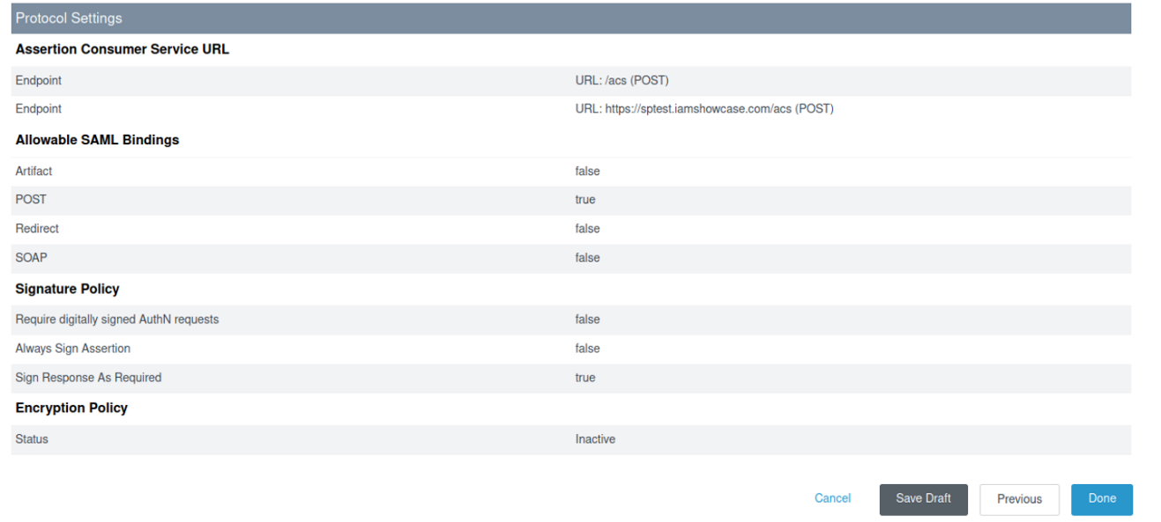

1. **Configure Certificate in SP Connection**
2. Navigate to **SP Connection Credentials** and select **Configure Credentials**

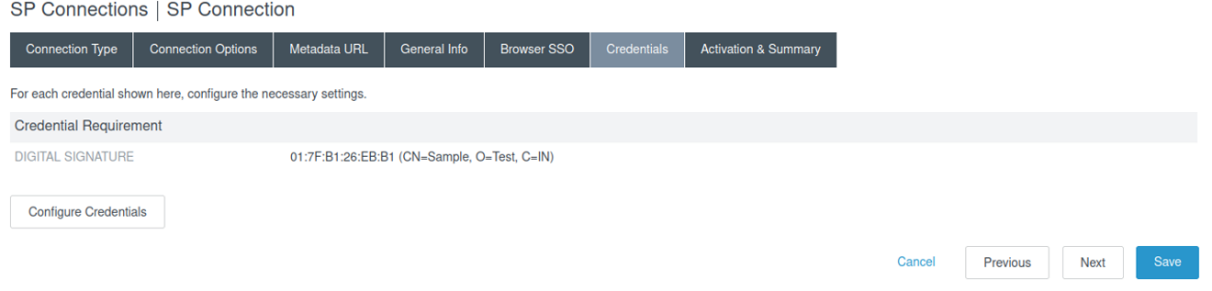

1. Navigate to **Digital Signature Settings** and select **Manage Certificates**

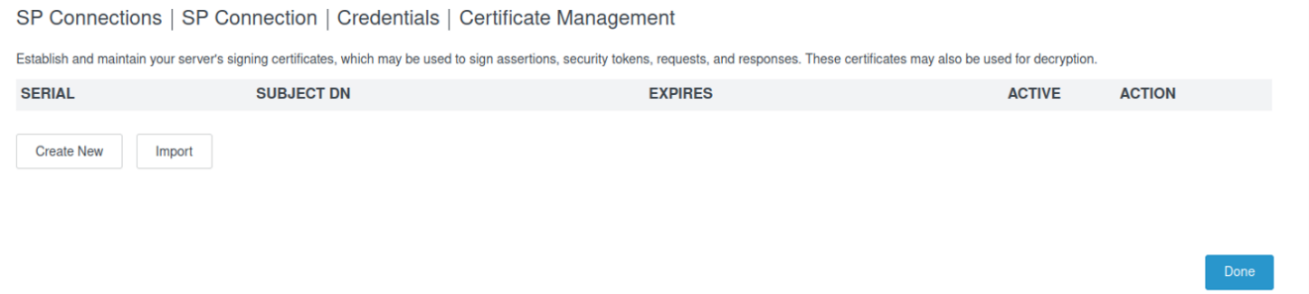

1. Select **Create New Option** and configure the following options as shown in the image.

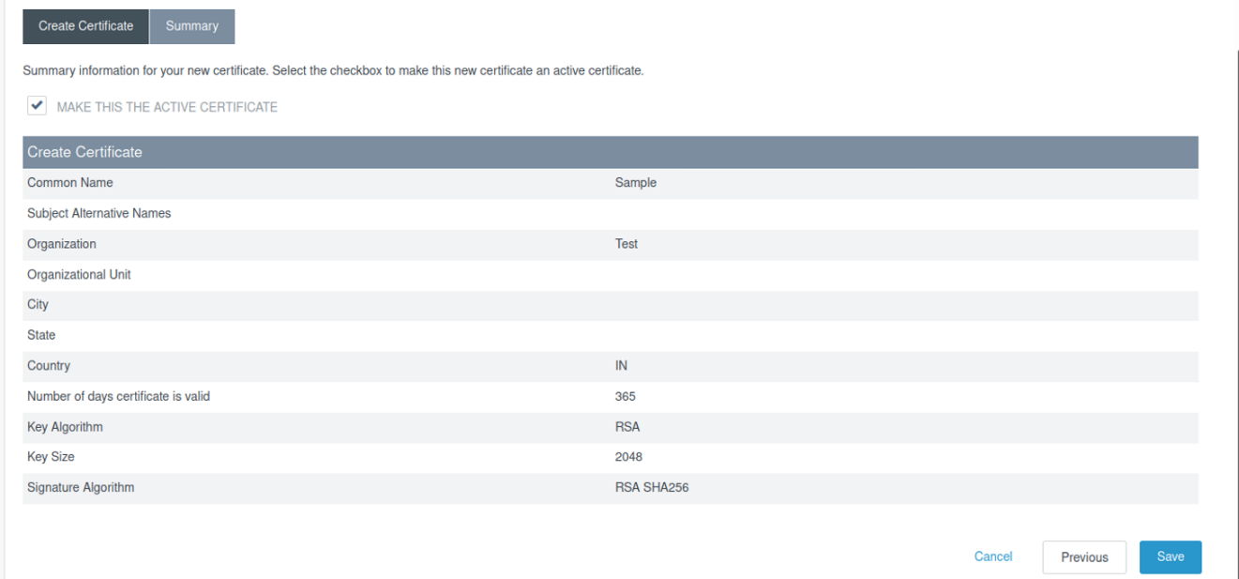

1. At this point we have created the certificate. Select **Done** to save the details of certificate.

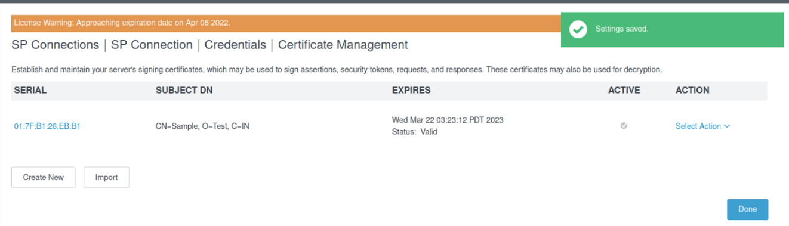

1. Select **Done** under the **Summary** tab of **Credentials**

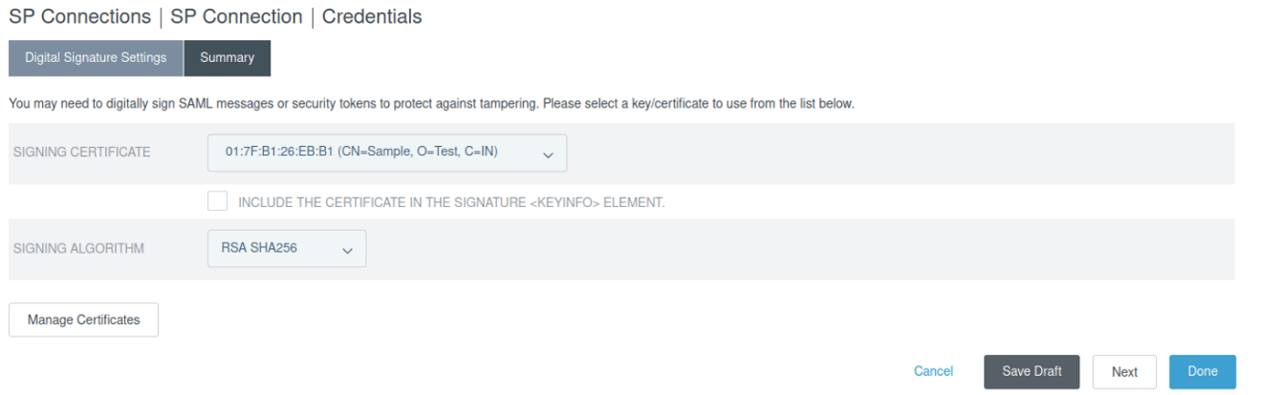

1. 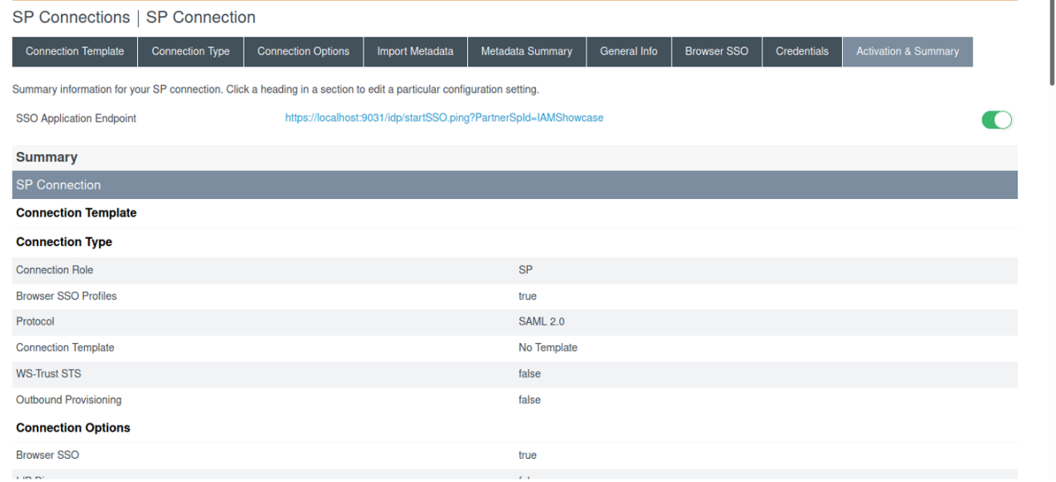Under the **Activation & Summary** tab, scroll down to view the summary and select **Done.**
2. **Access IdP Initiated SSO URL**
3. Navigate to **Applications SP Connections** and select Connection Name with **IAMShowcase**

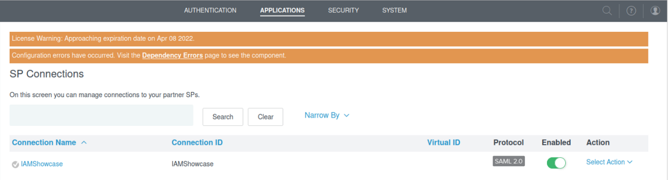

1. Click on the **SSO Application Endpoint** URL

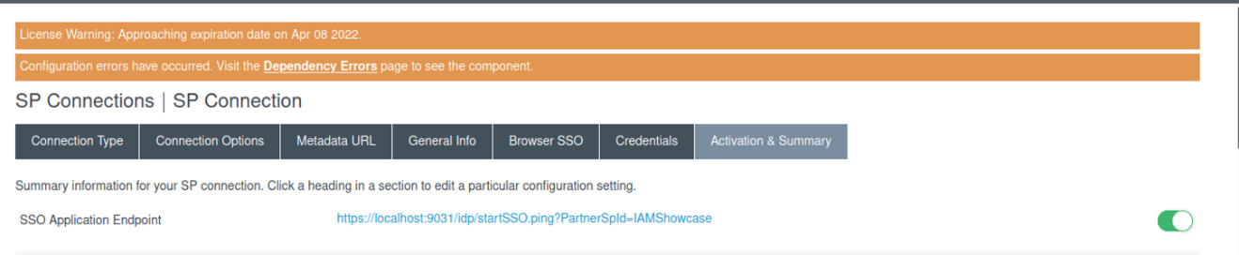

Note: This above URL shown in the image is an IDP Initiated URL.

1. Clicking the URL will redirect to the form page as shown below. Sign on with **USERNAME** and **PASSWORD** set up earlier in PCV steps.

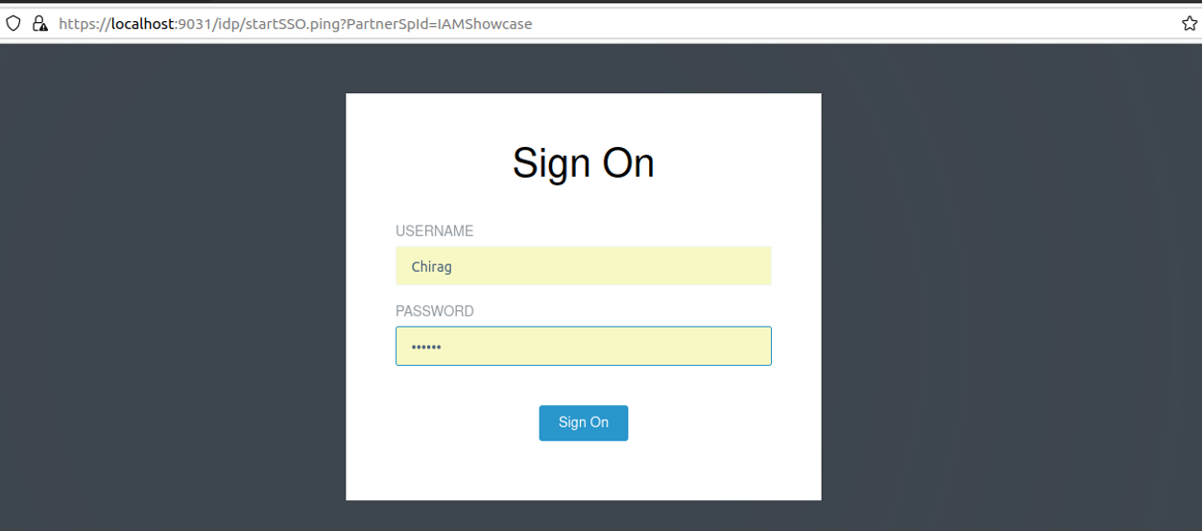

1. After signing in following web page will be displayed.

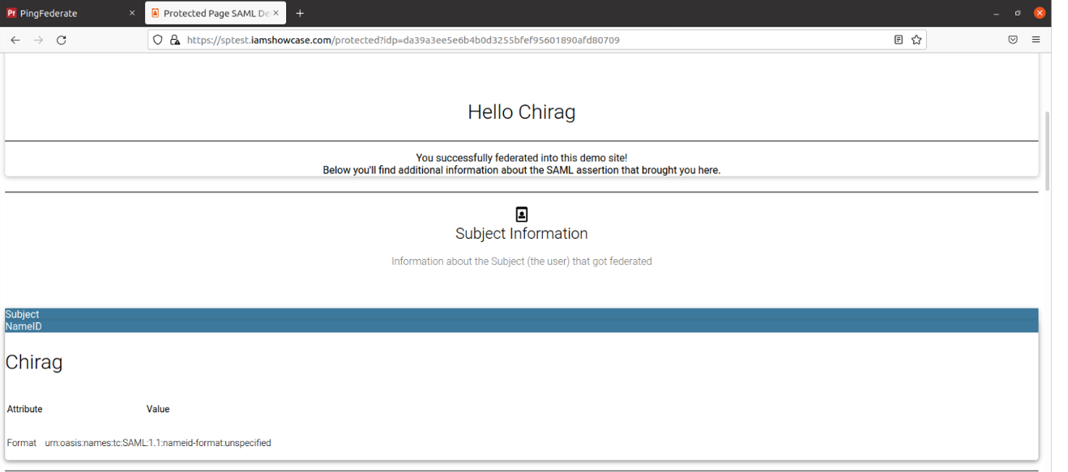

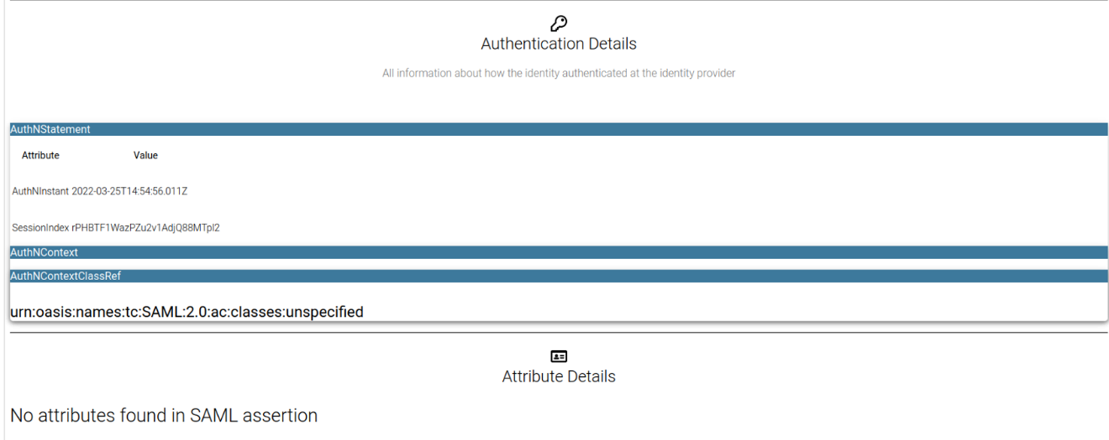

**Conclusion:** IDP Initiated SSO is successfully performed.

**PingFederate Installation Guide**

# Setting up a Virtual Machine

Download any Virtual Machine Software and set up any Linux distribution of your choice.

* Virtual Machine - VMware Workstation
* Linux Distro - Ubuntu

# Downloading JAVA

PingFederate requires a Java runtime to be installed on your server and has been tested in the following Java environments:

* Amazon Corretto 11
* Amazon Corretto 8
* OpenJDK 11
* Oracle Java SE Development Kit 11 LTS
* Oracle Java SE Runtime Environment (Server JRE) 8

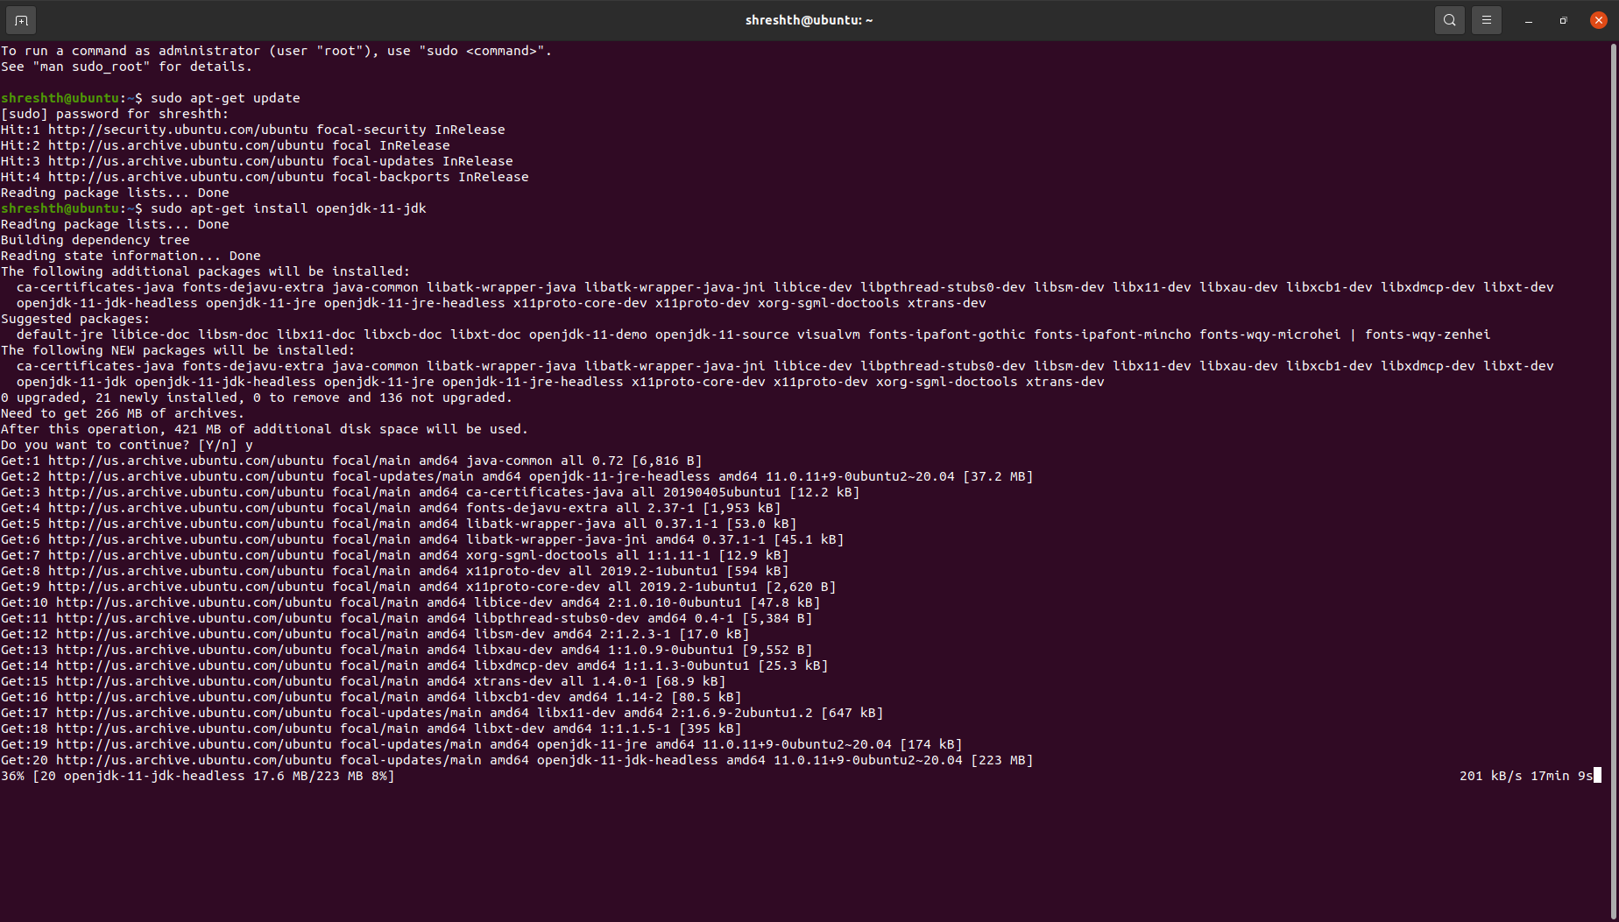One can install OpenJDK 11 on an Ubuntu by running **sudo apt-get install openjdk-11-jdk** in the terminal

# Downloading License Files

Request your license files for PingAccess, PingFederate and Ping Directory, one at a time, on this URL <https://www.pingidentity.com/en/account/request-license-key.html>

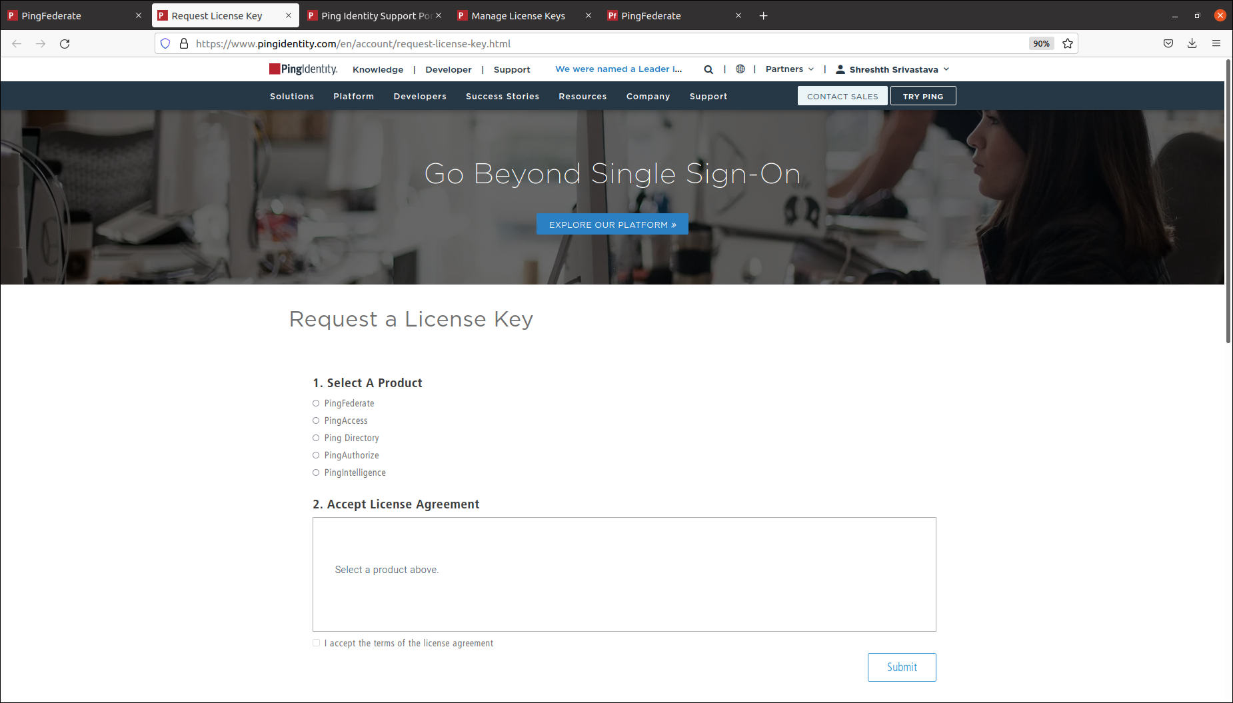

Once requested for all three license keys, download them by going to the Support Dashboard from this URL <https://support.pingidentity.com/s/>

Click on **MANAGE LICENSE KEYS → VIEW → DOWNLOAD** and download all the three requested license files respectively

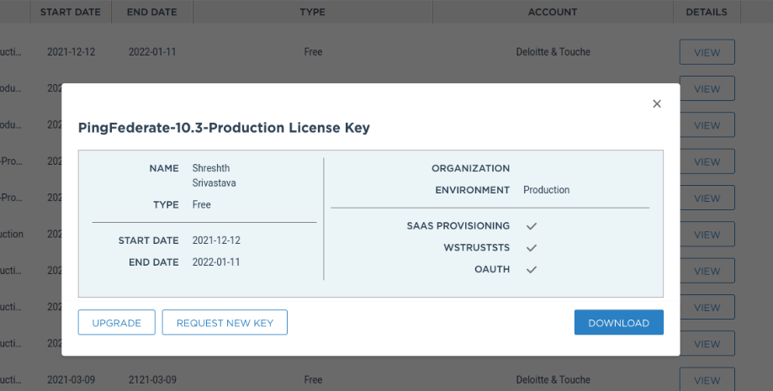

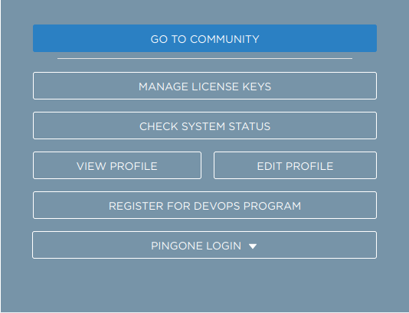

# PingFederate Installation

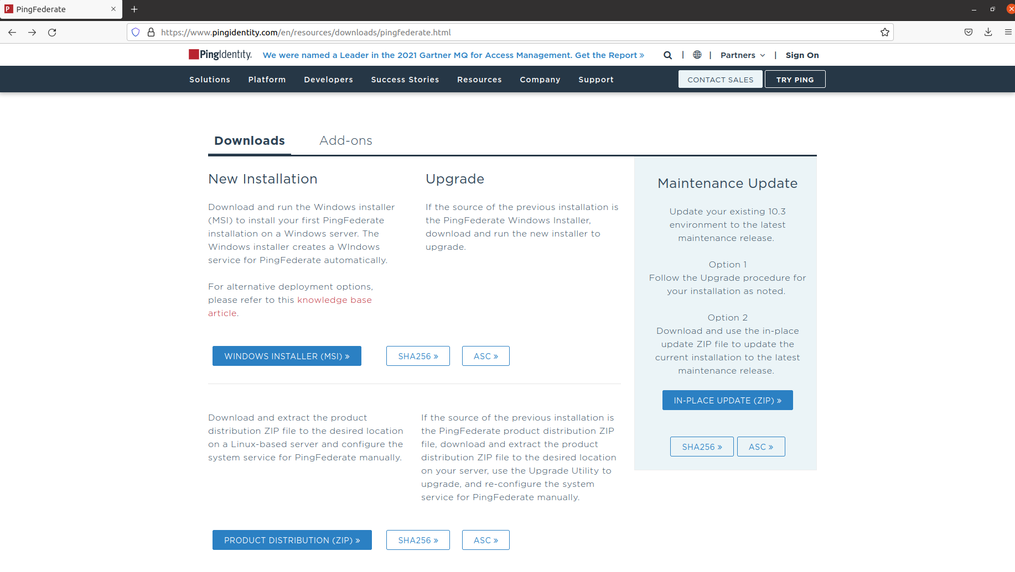Inside your VM, go to the URL <https://www.pingidentity.com/en/resources/downloads/pingfederate.html> and download the Linux-based Product Distribution (ZIP) file.

Extract the downloaded pingfederate zip file

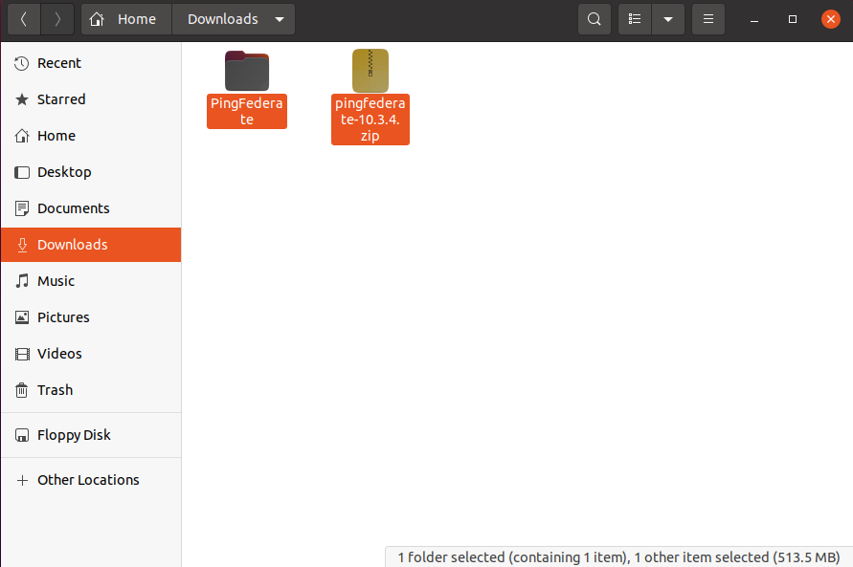

Go to the bin folder inside the extracted pingfederate folder and add the following line at the beginning of run.sh file

**JAVA_HOME="/home/chigaur/Downloads/openlogic-openjdk-11.0.8+10-linux-x64"**

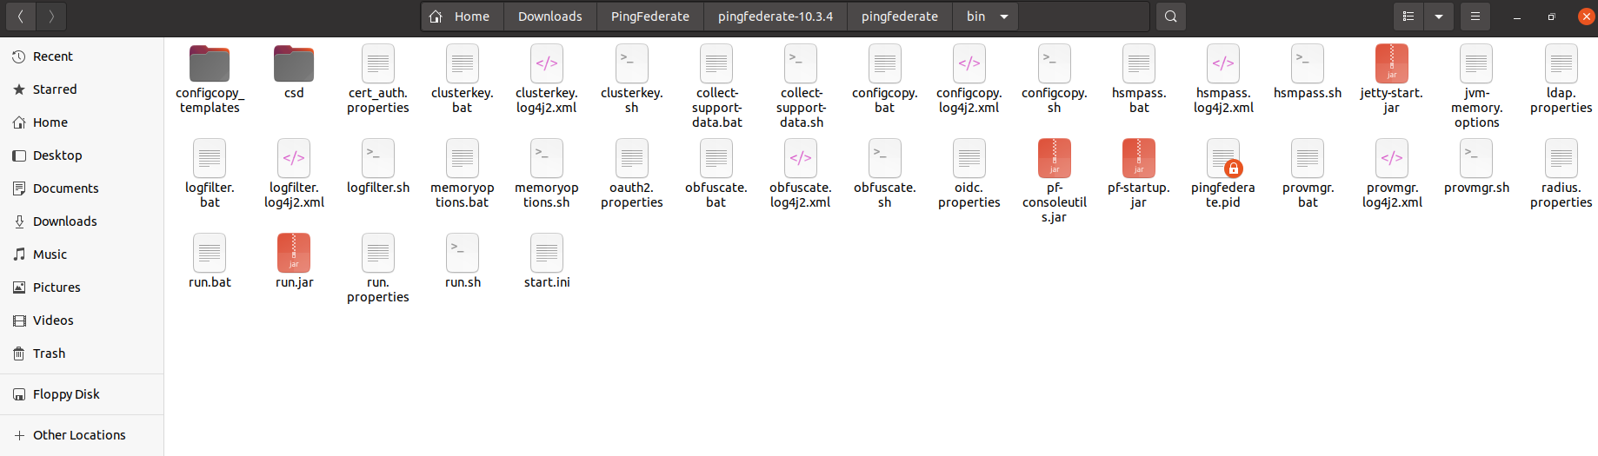

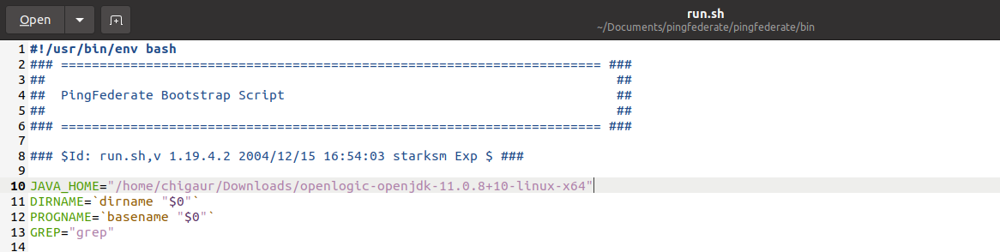

Then open the terminal inside the bin folder and type the command **sudo chmod +x run.sh**

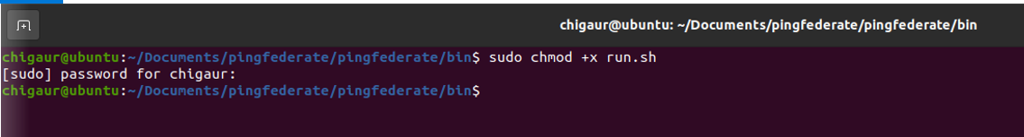

Run PingFederate by running the **sudo ./run.sh** command in the terminal

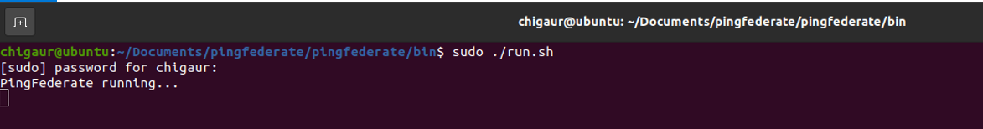

Open <https://localhost:9999/> to access the PingFederate console application

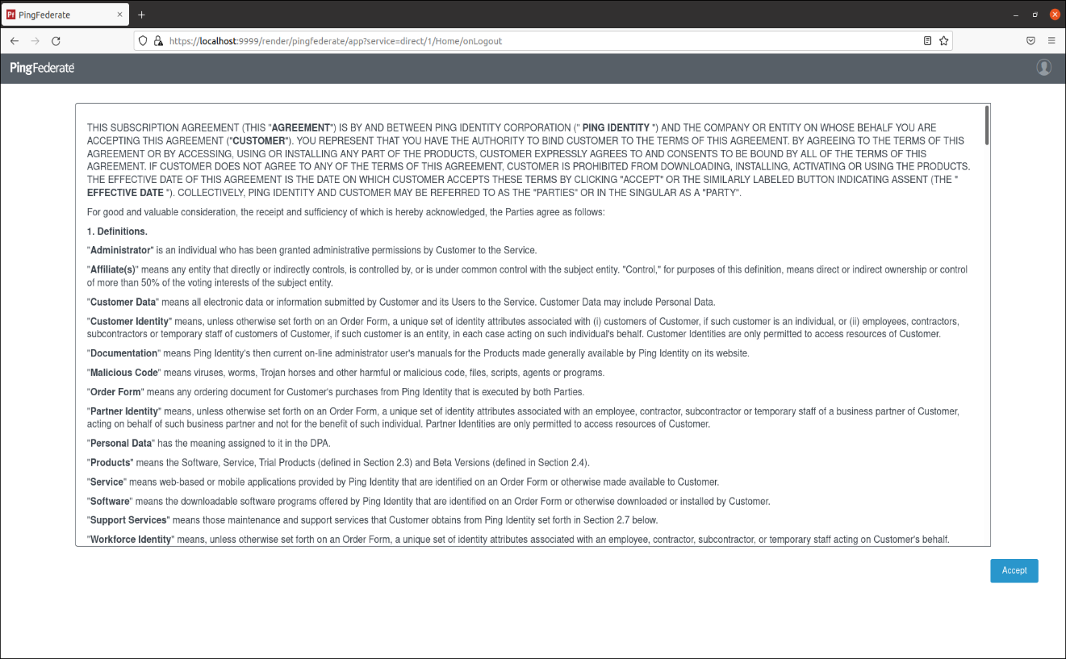

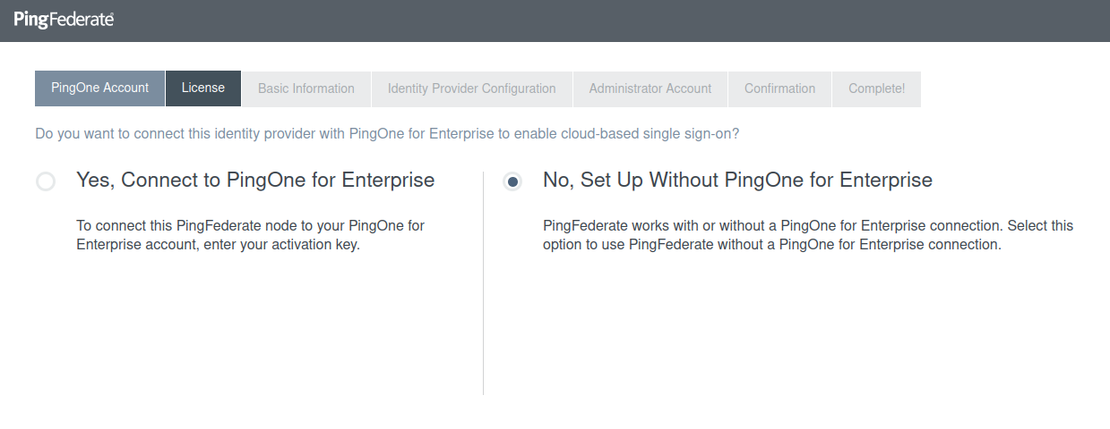Click on **Accept** and then select No, Set Up Without PingOne for Enterprise and click **Next**

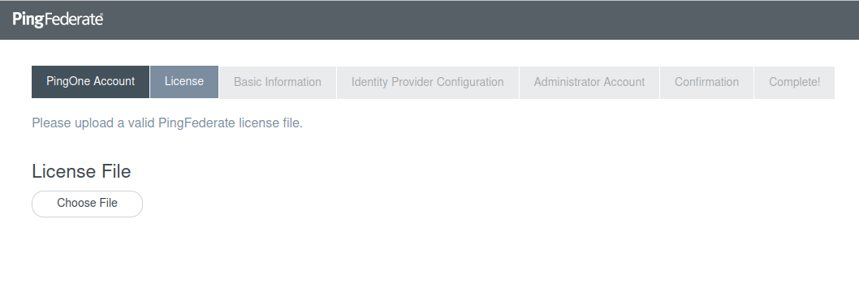Choose your license file and set up your PingFederate console with the default settings.

**Troubleshooting Issues**

1. **Openjdk Version not Supported**

* Few versions of Java JDK were not supported in my VM.
* 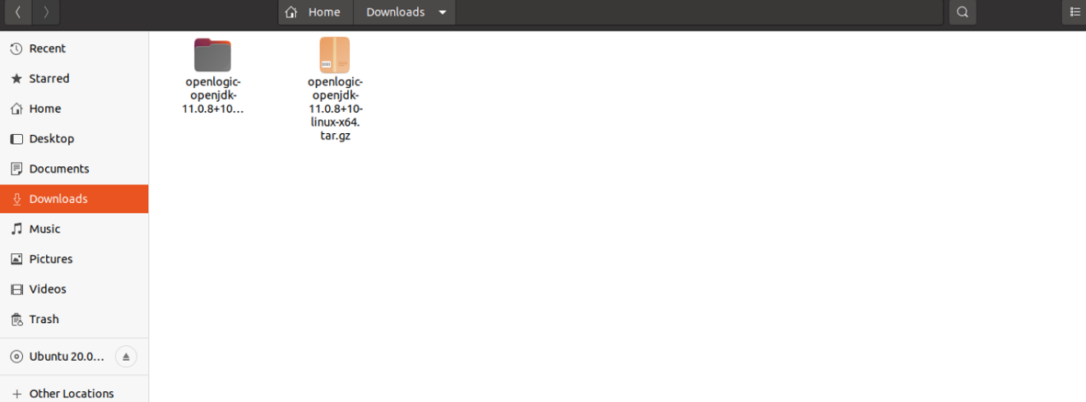I downloaded below mentioned version of openjdk. “openlogic-openjdk-11.0.8+10-linux-x64”

1. **Multiple Instances Running**

* 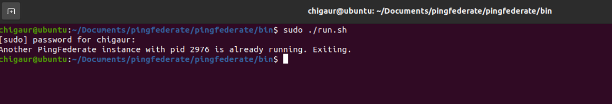When already an instance of pingfederate is running and if we try to run another instance of it then following error is shown as below.
* Kill command can be used to terminate the pingfederate instance.
* Command is **kill -9 pid**
* Here pid is the process id of pingfederate that is already running.

